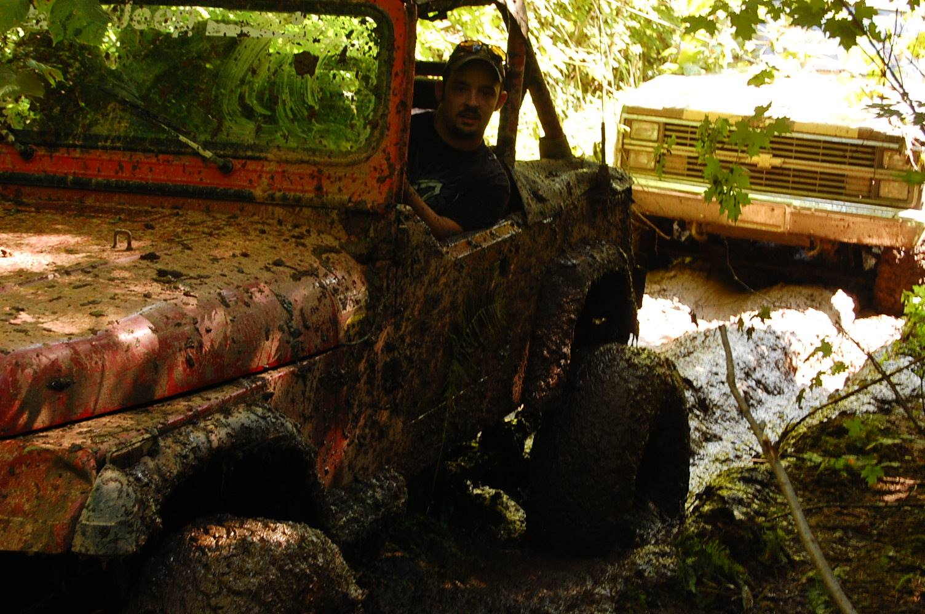

The John P. Oros Scholarship was created in the fall of 2016 in remembrance of John Oros. John was a maintenance technician for Cleveland Cliffs Mine and later part of the Ironworkers.

One of John’s passions was working on vehicles with his many friends. They pulled many all nighters swapping engines, building bodies and fixing someone’s broken rig.

The Auto Service and trade industries are in need of certified people who have a love and a passion for what John did. We hope this scholarship helps a young man or woman achieve that goal.

**John P. Oros Memorial Scholarship Qualifications and Submission Information**

1. The student applying must be either a current college student or a graduating senior from a high school in the Upper Peninsula, enrolled in an Upper Peninsula college – Tech, 2 or 4 year.
2. The student must reside in the Upper Peninsula.
3. The student must be enrolled in any Automotive Service/Tech program, welding program or Industrial Maintenance program.
4. The student must show proof of enrollment for the following semester upon application.
5. Application must include Application Form, 2 letters of reference, proof of enrollment papers and a 1 page essay on yourself and why you deserve this scholarship. Tell us about your passions and your career goals and why you chose the field that you did.

**Deadline: Extended to April 30**

All information must be mailed to:

John P. Oros Scholarship

HBAUP

3125 Wright Street

Marquette, MI 49855