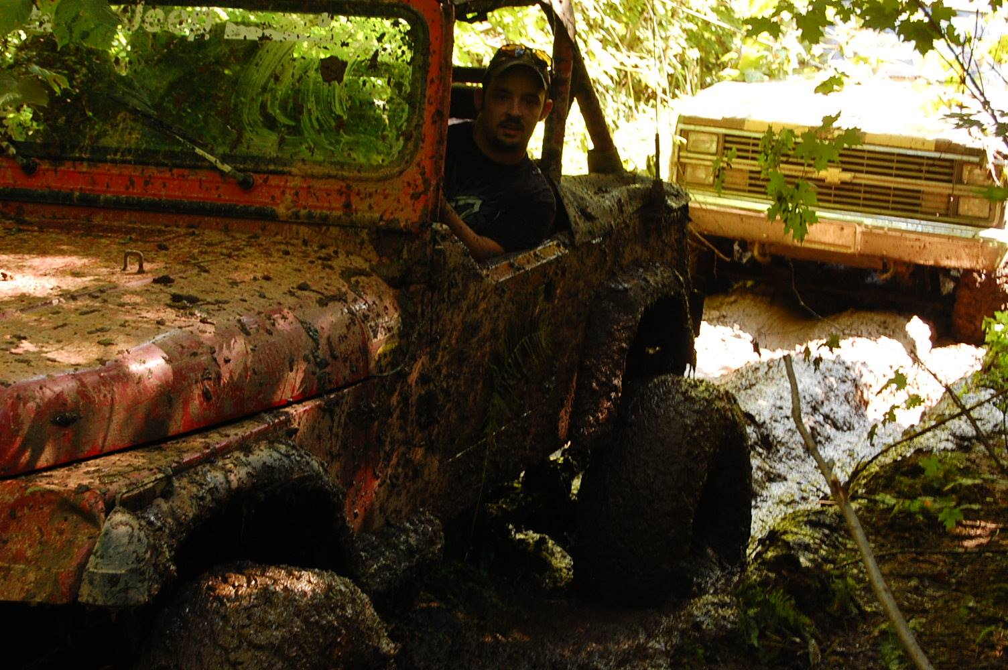

The John P. Oros Scholarship was created in the fall of 2016 in remembrance of John Oros. John was a maintenance technician for Cleveland Cliffs Mine and later part of the Ironworkers.

One of John’s passions was working on vehicles with his many friends. They pulled many all nighters swapping engines, building bodies and fixing someone’s broken rig.

The Auto Service and trade industries are in need of certified people who have a love and a passion for what John did. We hope this scholarship helps a young man or woman achieve that goal.

**John P. Oros Memorial Scholarship Qualifications and Submission Information**

1. The student applying must be currently attending a 2 or 4 year college and enrolled in one of the following programs: Welding, Industrial Maintenance, Auto Tech/any Auto program, Engineering in the construction industry – mechanical, civil, etc.
2. The student must show proof of enrollment/attendance for the following semester upon application.
3. Application must include Application Form, 2 letters of reference, proof of enrollment papers and a 1 page essay on yourself and why you deserve this scholarship. Tell us about your passions and your career goals and why you chose the field that you did.

**Scholarship to be awarded in May of 2020 for the Fall 2020 semester.**

**Deadline: April 15, 2020**

All information must be mailed to:

John P. Oros Scholarship

c/o Sarah Schultz

309 S Front Street, Ste 102

Marquette, MI 49855