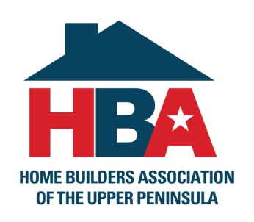
3125 Wright St, Marquette, MI 49855
Phone: 906-228-2312 / Fax: 906-228-8252
Sarah Foster, Executive Officer info@upbuilders.org

2021 HBA of the U.P. Angel Tree Program

Fall is upon us which means right around the corner, the holidays are coming. For the past 2 years, the Home Builders Association of the Upper Peninsula has been donating to families in need through their “Angel Tree Program”. Members of the HBA donate needed items to chosen families in need. We are accepting applications through October 15th for the 2021 Angel Tree Families. If you would like to apply, please follow the instructions below. You will be notified by the end of October if your family has been chosen. If you would like to nominate another family, just follow the same instructions. Shopping will take place in November and December and the families will have everything delivered to them in the 2nd half of December, before Christmas.

TO APPLY:
Send a letter to the HBA telling us your story and explaining why your family needs the assistance. Please see the attached form that needs to accompany your letter. Send your letter and form to the HBA by snail mail to the address above or email to info@upbuilders.org. Letters must be received or postmarked by October 15th. A panel of judges will read through the letters and decide how many and who gets chosen this year. If your family gets chosen you will be notified no later than the 1st week in November. If there are any questions, please use the same email above or call 906-228-2312.

Sincerely,

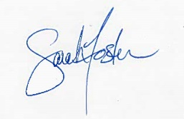
Sarah Foster
Executive Officer
Home Builders Association of the Upper Peninsula

