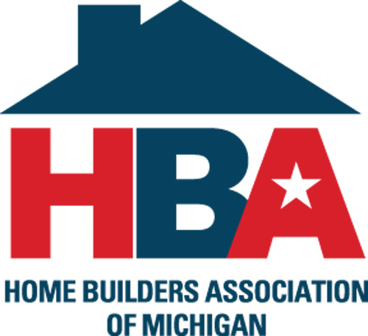

The Home Builders Association of Michigan (HBAM) has a multitude of programs, services and discounts that can help you run your business and save you money. You can find more information at hbaofmichigan.com including contact information for your local HBA.

These member-only programs include:

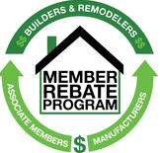 | Member Rebate Program - Earn several hundred dollars for each house by informing us of the products you use when you close on a home or remodeling project. Go to hbarebates.com or call toll-free (866) 849-8400. The average rebate now exceeds $1,500 per participant.
 | Discounted Workwear – Shop online at Getz’s and get special discounts on the work gear you need to get the job done. Carhartt, Wrangler and Keen Utility are just a few of the brands that are discounted. All discounted prices also run with current promotions. Go to www.getzs.com/hbam and use corporate code HBAGetzit.
 | Superfleet Gas Program - No charge fleet fueling program accepted nationwide with a 5 cents per gallon discount at all Speedway locations. Additional features include custom billing, weekly reporting and online account management to control your fleet. For more information, visit www.superfleet.net/mahb.
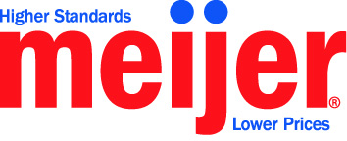 | Meijer Discount Savings - Build on Savings with the Meijer exclusive discount of 10% off all general merchandise through MPerks. Create a Meijer MPerks account and register at www.hbaofmichigan.com.
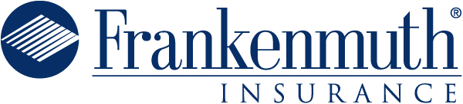 | Property & Casualty Insurance - Frankenmuth Mutual Insurance offers members a 10% discount on most lines and offers a rebate on the costs of subcontractor materials after an audit. Contact your local HBA for the endorsed agent in your area.
 | Workers’ Compensation Insurance – Frankenmuth Mutual Insurance provides Workers' Compensation insurance for builders and contractors. Policyholders enjoy free loss prevention and safety services offered by a team of professional consultants. Contact your local HBA for the endorsed agent in your area.
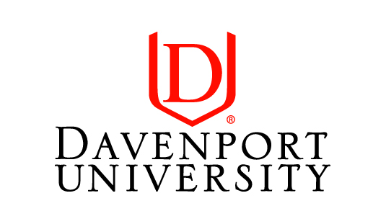 | College Tuition Discount – Davenport University offers a 20% tuition discount for all HBAM members, employees, spouses and dependents. Earn a graduate, undergraduate or associate degree in business, technology or health. Call (800) 686-1600 or visit www.davenport.edu/IPEx for more information. Contact diana@hbaofmichigan.com for a membership verification letter.
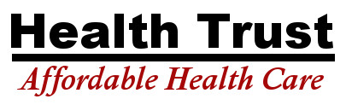 | Group Health Insurance – The ABC / HBA Health Trust is offering affordable insurance options to association members. Members can pool their resources through the Trust to provide health and welfare benefits similar to those available through very large employers. Contact the HBAM office at (517) 322-0224.
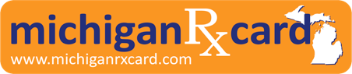 | Discount Prescription Card - Save up to 75 percent on your prescription drugs with acceptance at 68,000 pharmacies nation-wide. Michigan Rx Card is pre-activated for immediate savings with no paperwork to complete, no health restrictions and no usage limitations. Get more information and print out your card from www.hbaofmichigan.com
 | National Affinity Programs – The National Association of Home Builders provides discounts from GM, Dell, Verizon, Office Depot, UPS, FTD, Hertz and many others. Go to www.nahb.org/ma for more information on these programs. All programs, rates and prices are subject to change without notice.

